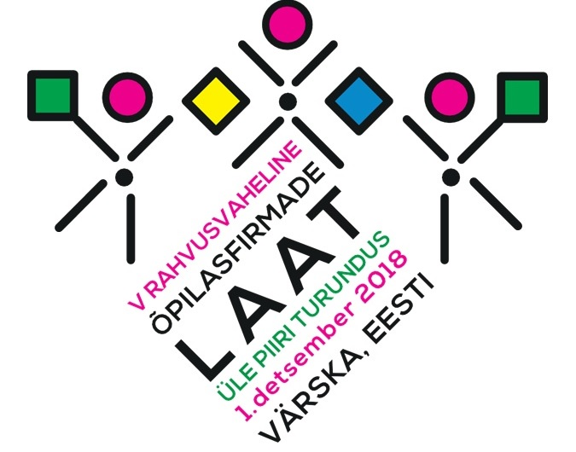
5th International Student Trade Fair
Marketing Across Borders
December 1st, 2018
Värska, Estonia

Program:

9.00  11.00 Preparing the stands at Värska Culture Center
11.00 Opening Trade Fair
11.00  15.00 Selling
13.00  13.30 Lunch at Värska Gymnasium
15.00  15.30 Awards Ceremony and Closing

Important information for participants:

- Only students registered at the fair can participate.
- One company is represented by 2-4 members and one supervisor.
- Registration for participation at the student fair is open until November 19th, 2018 (please send the completed registration forms to ingrit@setomaa.ee).
- Selling products is allowed only in a booth.
- Each company has the opportunity to promote themselves on the stage for 3-5 minutes, timetable will be provided by the organizers in advance.
- Each company will organize their own transportation to the venue and is responsible for their own goods and personal items during the fair.
- Each company will take all the necessary items with them in order to decorate the booth.
- In order to have access to electricity, all the companies must have their own extension chords and must notify the organizers no later than November 19th.
- The organizing committee will determine the location for each company during the fair.
- Setting up the materials must not damage the walls. Student company members are responsible for the removal of the decorations, ensuring that the walls and floor of the booth are clean and the trash is taken to the garbage bins.
- The dimensions of the booth: each booth has two walls (width 1m x height 2.5 meters). The dimensions of the sales table: 0.6m x 1.2m.
The jury will select the best in each category:

- the best mini company
- the best student company
- the best sales strategy
- the best product
- the best service
- the most stylish exposition
- the best Setomaa company

More information: FB: www.facebook.com/ulepiiriturundus, e-mail: ingrit@setomaa.ee,
mob: +3725120659

Organizer: Setomaa Liit

